BROWSER SECURITY (CLIENT-SIDE)
The browser is the first line of defense.
Its main goals are:
- Protect the user’s system
- Prevent one website from stealing data from another
- Block malicious code execution
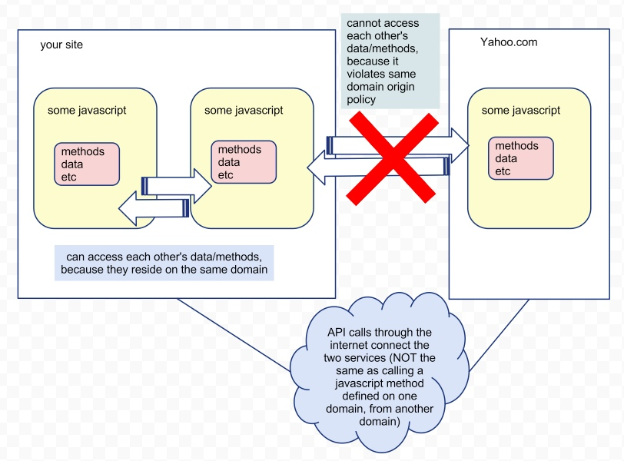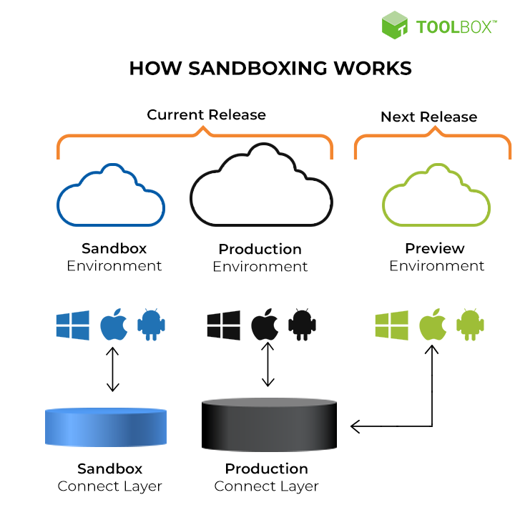

1. Security Sandbox
What It Is
A sandbox is an isolated environment where browser code runs.
How It Works
- JavaScript and web content run inside the browser only
- No direct access to:
  - Files
  - OS memory
  - Installed applications
Why It Matters
Even if a website is malicious:
- It cannot install malware
- It cannot read your local files
Real-World Threat
- Sandbox Escape
Attackers exploit browser engine bugs to break isolation.
Defense
- Keep browsers auto-updated
- Avoid outdated or unsupported browsers

2. Same-Origin Policy (SOP)
What Is an Origin?
An origin =
Protocol + Domain + Port
Example:
https://bank.com:443
How SOP Works
- Scripts from attacker.com
- Cannot read data from bank.com
Even if both are open in different tabs.
Attack Prevented
- Cross-site data theft
- Session stealing
- Unauthorized API reads
Common Bypass (Misconfiguration)
- Bad CORS settings
- Access-Control-Allow-Origin: * on sensitive APIs
Secure Practice
- Allow specific trusted domains only
- Never allow wildcard origins for authenticated APIs

3. Content Security Policy (CSP)
What CSP Does
CSP tells the browser:
“Load scripts, images, and styles ONLY from trusted sources.”
Why CSP Is Powerful
It Stops:
- Cross-Site Scripting (XSS)
- Inline script injection
- Third-party malicious scripts
Example Scenario
Injected code:
<script src="evil.com/steal.js"></script>
If CSP is strict → Browser blocks it
Secure CSP Rules
- Disable unsafe-inline
- Allow scripts only from your domain
- Use nonces or hashes for scripts

4. HTTPS and TLS Encryption
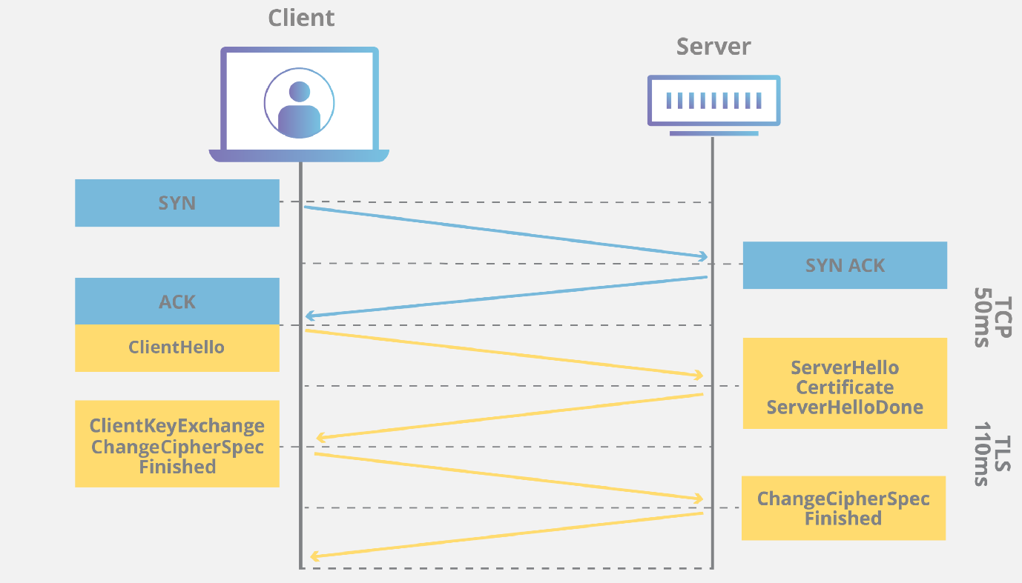

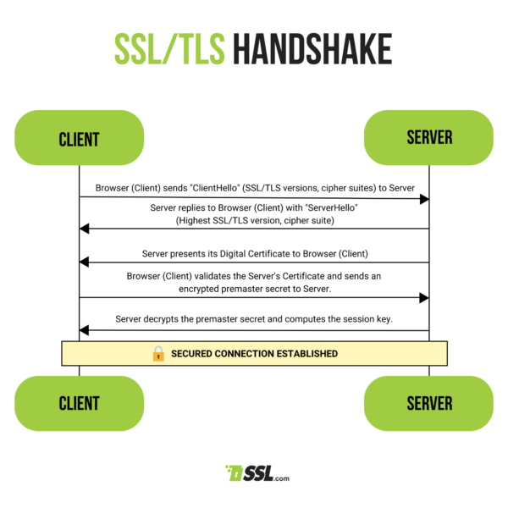

5. Cookie Security Controls
What Cookies Store
- Session tokens
- Login state
- Preferences
Attacks
- XSS stealing cookies
- Packet sniffing on HTTP
Secure Cookie Flags
Flag | Purpose
HttpOnly | Blocks JS access
Secure | HTTPS only
SameSite | Prevents CSRF
6. Phishing & Malware Protection
Browser Protection Includes
- Google Safe Browsing
- Malware site blocklists
- Download warnings
Benefit
Stops users before damage happens

7. Third-Party Cookie Blocking
Why It Exists
- Prevents cross-site tracking
- Stops behavioral profiling
Security Gain
- Reduced attack surface
- Less session correlation risk

8. Automatic Updates
Why They Matter
Most browser attacks exploit known vulnerabilities
Automatic Updates
- Patch zero-days fast
- Close sandbox escape bugs

9. Security Warnings
Browsers warn users about:
- Invalid SSL certificates
- Dangerous downloads
- Deceptive sites
These warnings save users who don’t understand security

10. Password Managers
Advantages
- Strong passwords
- Auto-fill protection
- No reuse
Risk
- Device compromise = password exposure
Best Practice
- Strong OS lock
- Use master password or biometric

SECTION 2: SERVER-SIDE SECURITY
Server-side security protects:
- Business logic
- Databases
- APIs
- User data
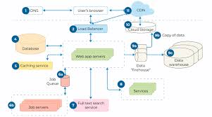

1. Web Server (Apache / Nginx)
Role
- Entry point for HTTP requests
- Routes traffic to backend services
Common Attacks
- DDoS flooding
- Directory traversal (../../)
- Server version leakage
Defense
- Rate limiting
- Disable directory listing
- Hide server banners

2. Application Server
Role
- Handles logic
- Authentication
- Authorization
Attacks
- SQL Injection
- Command Injection
- Insecure deserialization
Defense
- Input validation
- Secure frameworks
- Safe object handling

3. APIs
Role
- Connect frontend ↔ backend
- Power mobile & web apps
Attacks
- Broken authentication
- No rate limits
- Data overexposure
Defense
- OAuth / JWT
- API gateways
- Strict schema validation

4. Middleware
Role
- Auth checks
- Logging
- Request modification
Risk
- Bypass if misconfigured
Defense
- Least privilege
- Secure order of execution

5. Caching (Redis / Memcached)
Purpose
- Performance boost
Attacks
- Cache poisoning
- Sensitive data exposure
Defense
- Authenticated access
- Avoid storing secrets

6. Database Security
Attacks
- SQL Injection
- Weak credentials
- Data exposure
Defense
- Parameterized queries
- RBAC
- Encryption at rest

SQL Injection – Attack Flow Explained
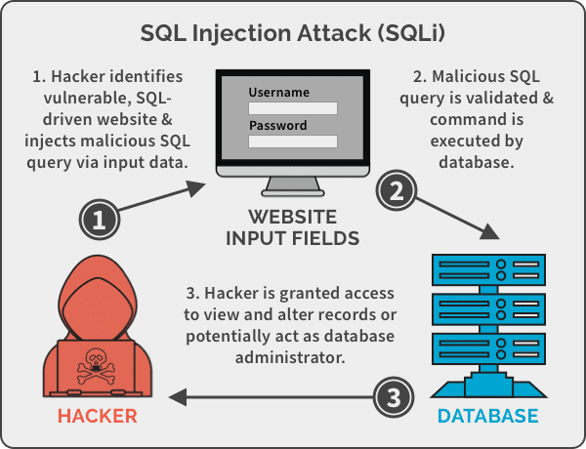

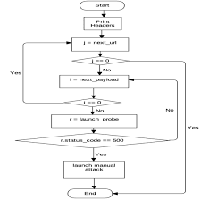
Step-by-Step Flow
- User input directly added to SQL query
- Attacker injects logic (OR 1=1)
- Database executes attacker logic
- Authentication bypassed
Secure Solution
- Prepared statements
- ORM usage
- Input sanitization

Cross-Site Scripting (XSS) – Server Failure
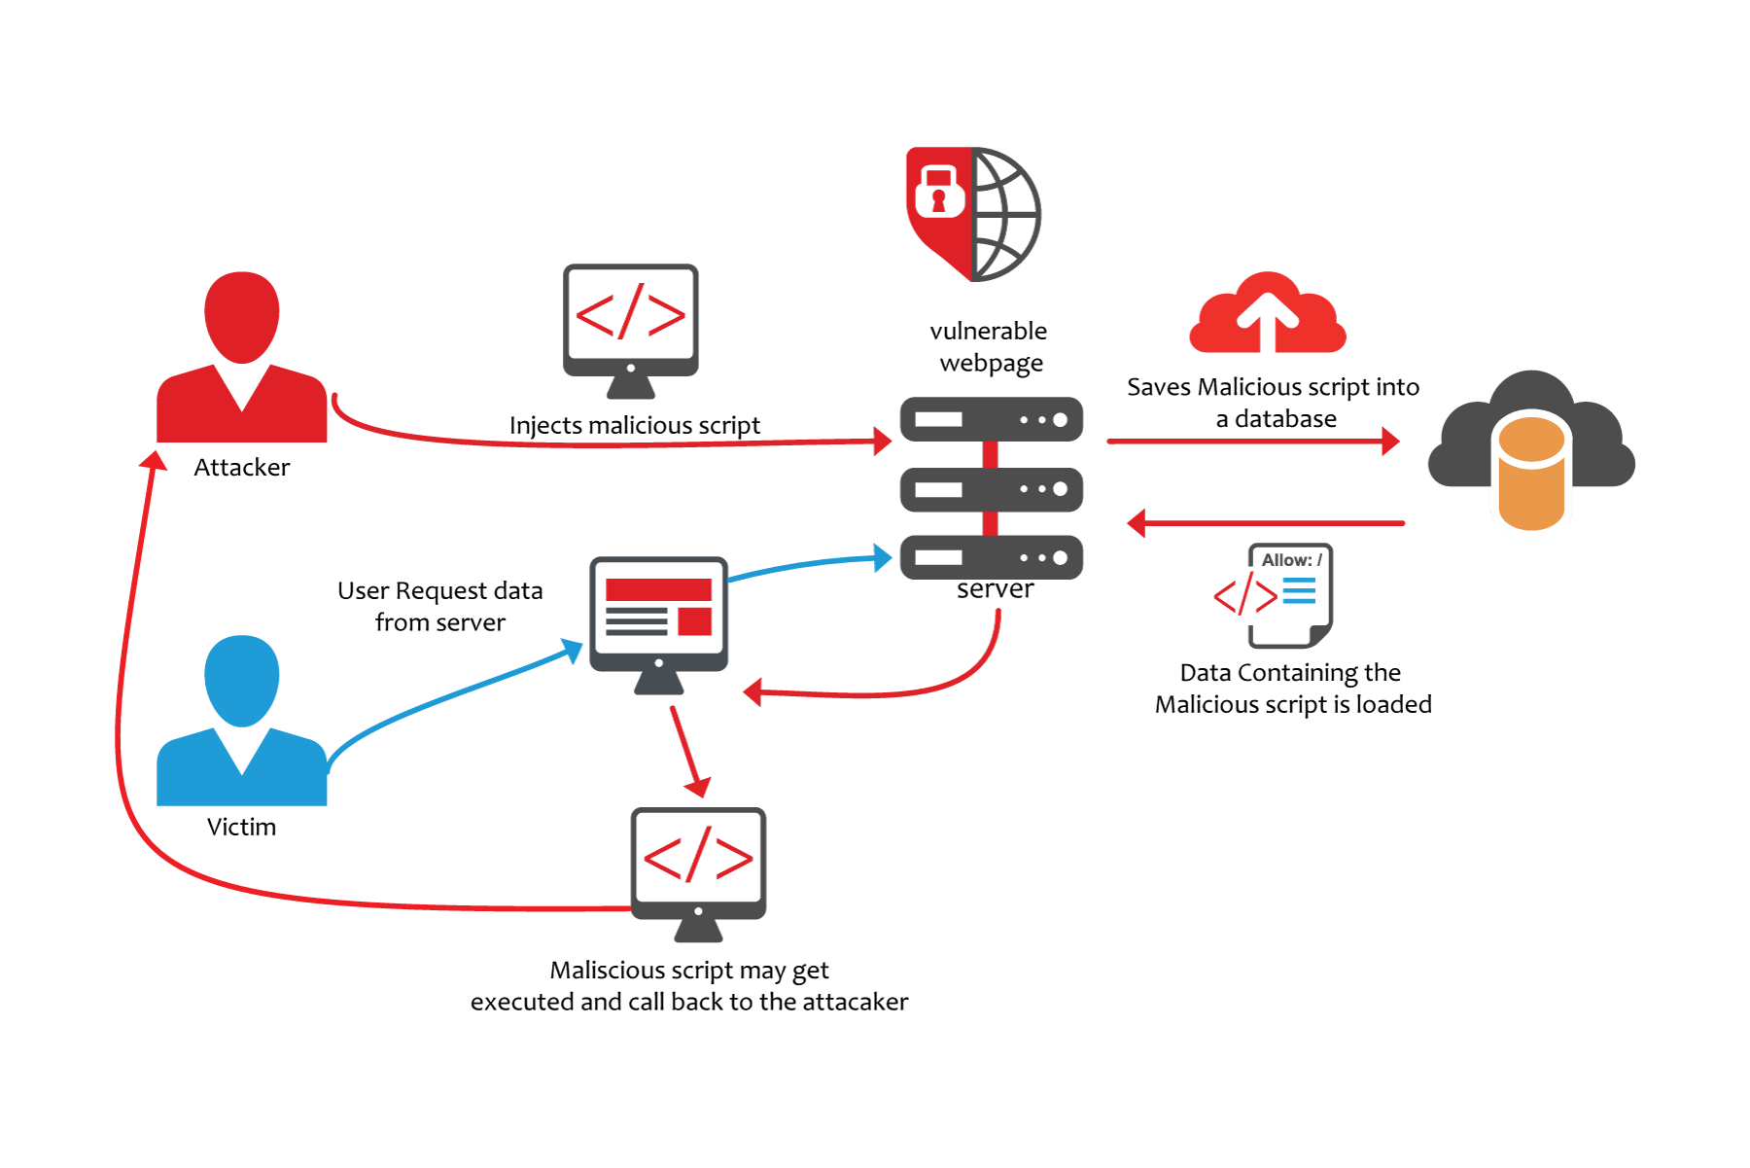
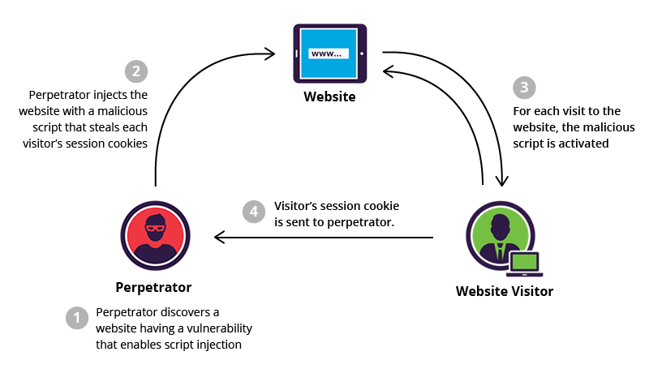
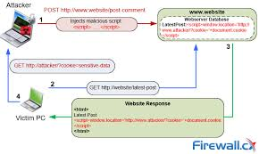
Stored XSS Flow
- Attacker submits malicious input
- Server stores it without validation
- Victim loads page
- Browser executes attacker script
Defense
- Output encoding
- CSP
- Input sanitization

Broken Authentication & Sessions
Attacks
- Credential stuffing
- Predictable session IDs
- No MFA
Defense
- Multi-Factor Authentication
- Secure random session tokens
- Session expiration

Final Summary
Layer | Key Protection
Browser | Sandbox, SOP, CSP, HTTPS
Server | Validation, Auth, Encryption
Database | Parameterized queries
APIs | Auth + Rate limits

